**Project Design Phase-II**

**Technology Stack (Architecture & Stack)**

|  |  |
| --- | --- |
| Date | 03 October 2022 |
| Team ID | PNT2022TMID23535 |
| Project Name | Gas Leakage Monitoring and Alerting System for Industries |
| Maximum Marks | 4 Marks |

**Technical Architecture:**

The Deliverable shall include the architectural diagram as below and the information as per the table1 & table 2

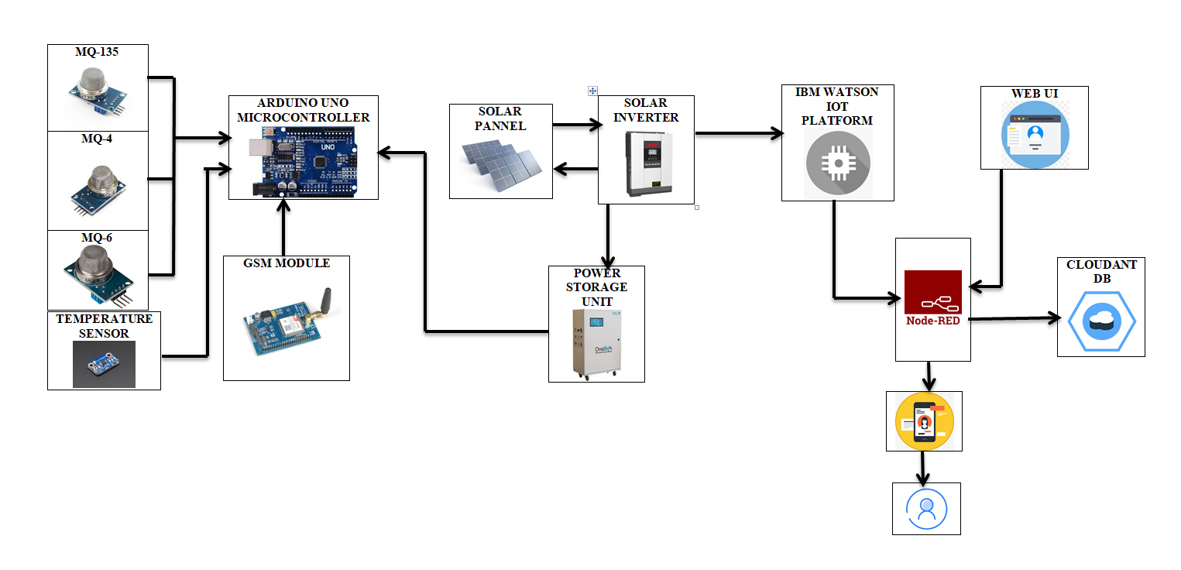

**Table-1 : Components & Technologies:**

|  |  |  |  |
| --- | --- | --- | --- |
| **S.No** | **Component** | **Description** | **Technology** |
|  | User Interface | Web UI will contain previous gas levels , Mobile App, is used to notify the workers about the gas concentrations levels in case of leakage | HTML, CSS, JavaScript |
|  | Application Logic-1 | Logic for a process in the gas sensors MQ-4, MQ-6, MQ-135 | C# / Python |
|  | Application Logic-2 | Logic for a process in temperature sensor | C# / Python |
|  | GSM | The GSM Module is directly connected to the microcontroller as the logic levels of both the GSM Modem and Microcontroller are already matched in the GSM Module Board. If there is no level converter on the board, then we need to use MAX232 level converter as a mediator between Controller and GSM to transfer the data. | C# / Python |
|  | Database | Analysis is done using graphs using the sensor values stored in database. It shows the graph between gas concentration and the temperature at that time. | MySQL |
|  | Cloud Database | Database Service on Cloud | IBM Cloudant |
|  | File Storage | File storage requirements To store the data of periodic gas levels | IBM Block Storage |
|  | Controller Board | Purpose of Arudino Microcontroller is to integrate all the components with the cloud | C# / Python |
|  | External API-1 | Purpose of External API used in the application to monitor the position of gas leakage | Google maps for Geolocation |

**Table-2: Application Characteristics:**

| **S.No** | **Characteristics** | **Description** | **Technology** |
| --- | --- | --- | --- |
|  | Open-Source Frameworks | Multilingual and User-friendly application for customers | Technology of Opensource framework |
|  | Security Implementations | The system data is kept secure, store data and responds to attack with help of Transport layer Security Protocol | e.g. SHA-256, Encryptions, IAM Controls, OWASP etc. |
|  | Scalable Architecture | The system can respond to change in demand | Technology used |
|  | Availability | Leak detectors are easy -to -use and easy-to-operate cloud based software system to monitor leakage | Technology used |
|  | Performance | The system provides better speed and efficiency irrespective of the workload | Technology used |

**References:**

[**https://c4model.com/**](https://c4model.com/)

[**https://developer.ibm.com/patterns/online-order-processing-system-during-pandemic/**](https://developer.ibm.com/patterns/online-order-processing-system-during-pandemic/)

[**https://www.ibm.com/cloud/architecture**](https://www.ibm.com/cloud/architecture)

[**https://aws.amazon.com/architecture**](https://aws.amazon.com/architecture)

[**https://medium.com/the-internal-startup/how-to-draw-useful-technical-architecture-diagrams-2d20c9fda90d**](https://medium.com/the-internal-startup/how-to-draw-useful-technical-architecture-diagrams-2d20c9fda90d)